Surveillance-based R(t) estimation for respiratory pathogen onset detection: a retrospective cross-pathogen evaluation of influenza and RSV in Hong Kong, 2014–2026
Thomas Yuan, Vijaykrishna Dhanasekaran
Figures 1 to 4
Version: 2026-09-26, v9 (supersedes figures_v8 of 25 August 2026). All values generated from the repository at https://github.com/thomasshuaiyuan/pinn-early-warning.
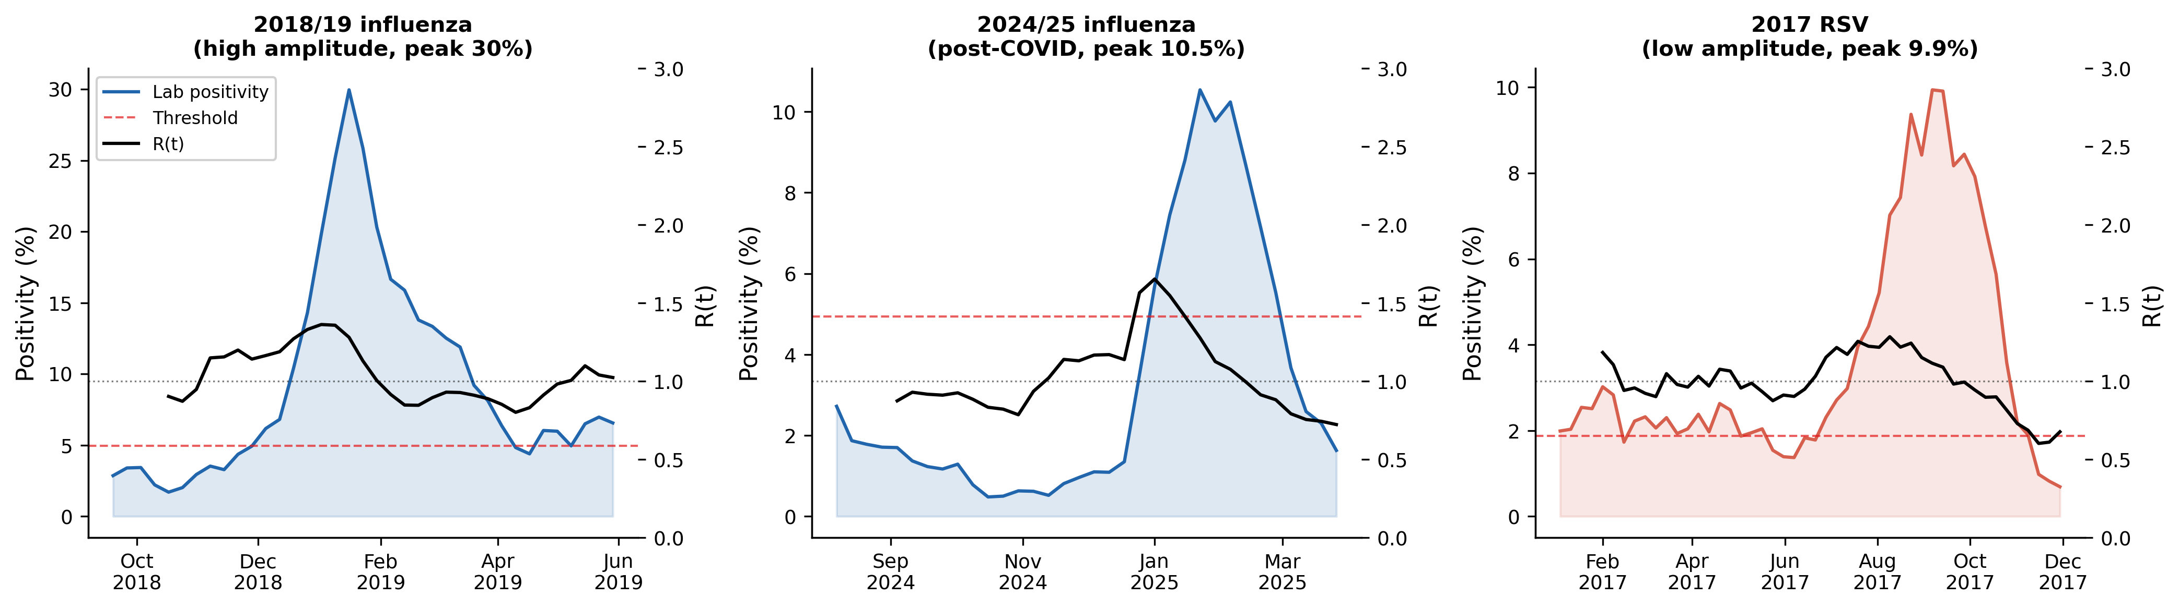
Figure 1. Representative R(t) trajectories. Weekly laboratory positivity (shaded) and EpiEstim posterior mean R(t) (black) for a high-amplitude influenza season (2018/19, peak 30.0%), a low-amplitude post-COVID influenza season (2024/25, peak 10.5%) and an RSV season (2017, peak 9.9%). Dashed line: onset comparator (CHP 4.94% for influenza; data-derived 1.87% for RSV). Dotted line: R(t) = 1.

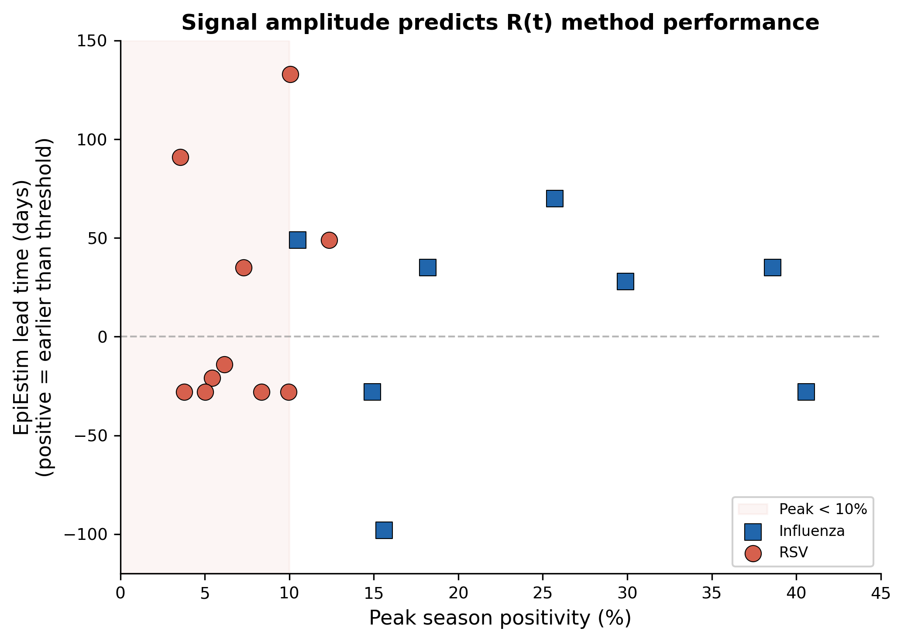
Figure 2. Signal amplitude and EpiEstim onset performance. EpiEstim lead time relative to the onset comparator (positive = earlier than the threshold) against peak season positivity for 8 influenza seasons (squares) and 10 RSV seasons (circles). Shaded region: peak positivity below 10%. The corresponding signal-to-noise analysis is reported in the Results.

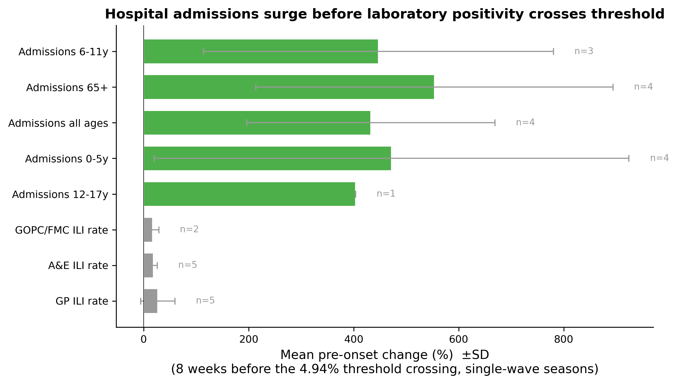
Figure 3. Pre-onset amplification by surveillance channel. Mean percentage change (bars, with SD) in each channel over the 8 weeks before laboratory positivity crossed the CHP 4.94% threshold, single-wave influenza seasons; n is the number of seasons contributing a value. Values are listed in Supplementary Table S2.

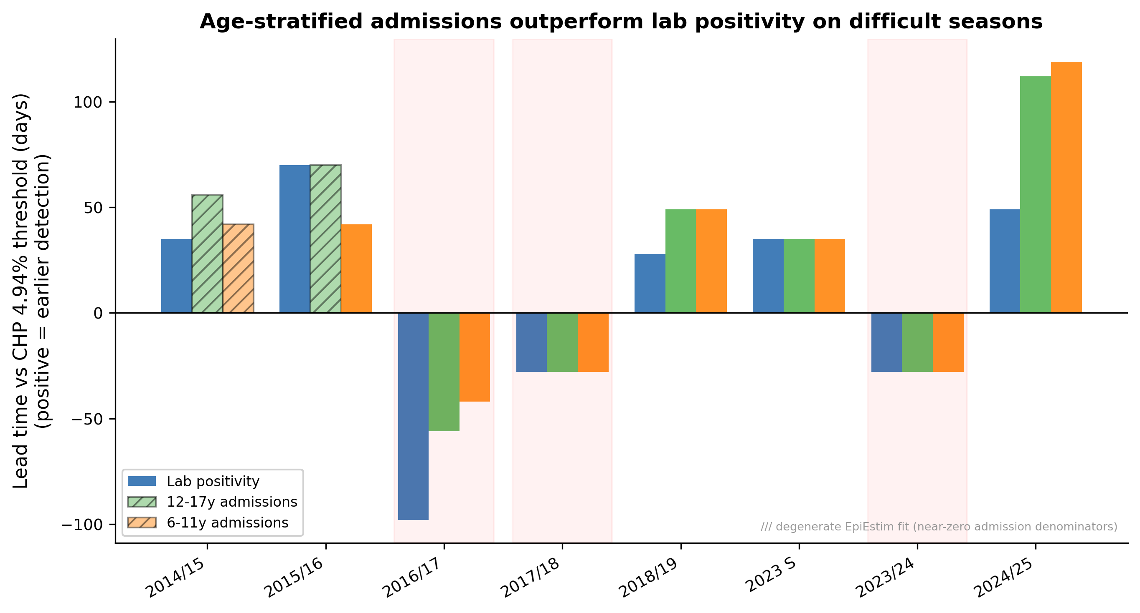
Figure 4. Admissions-based versus positivity-based onset detection. EpiEstim lead time relative to the CHP 4.94% threshold for laboratory positivity and for 12–17 and 6–11 year hospital admissions across 8 influenza seasons (positive = earlier detection). Hatched bars: degenerate EpiEstim fits caused by near-zero admission denominators (2014/15 and 2015/16). Shaded seasons: multi-wave (2016/17, 2017/18, 2023/24).

